Putin Positive:

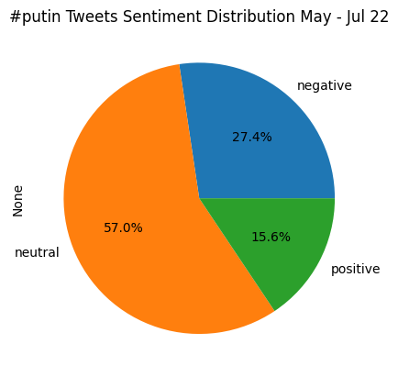

Putin Negative:

Zelensky Positive:

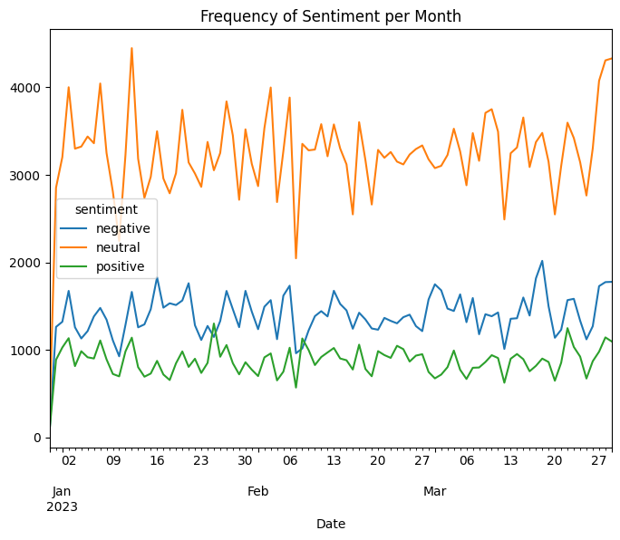

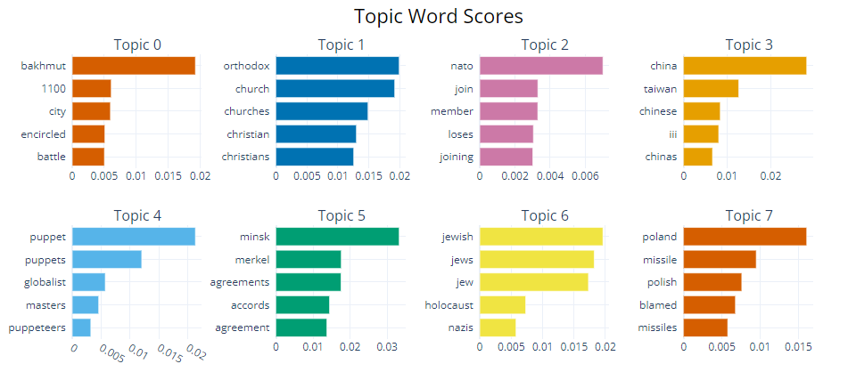

Zelensky Negative:

Ukraine Positive:

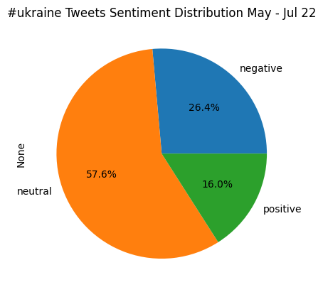

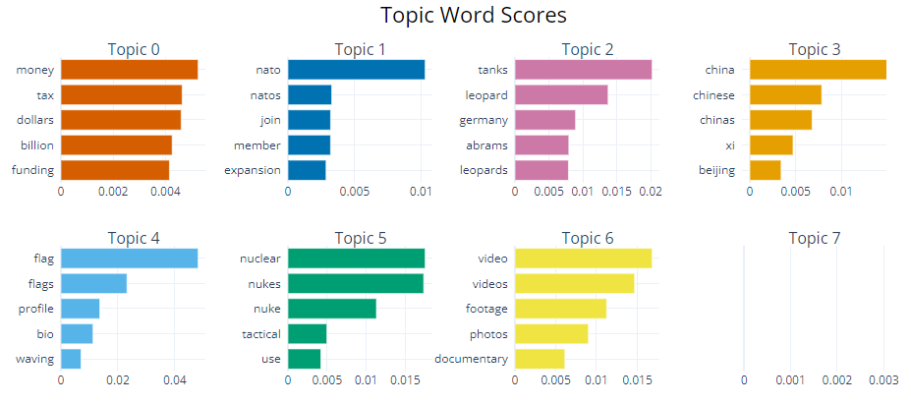

Ukraine Negative:

